That Burns

Love

In Every Human

Heart

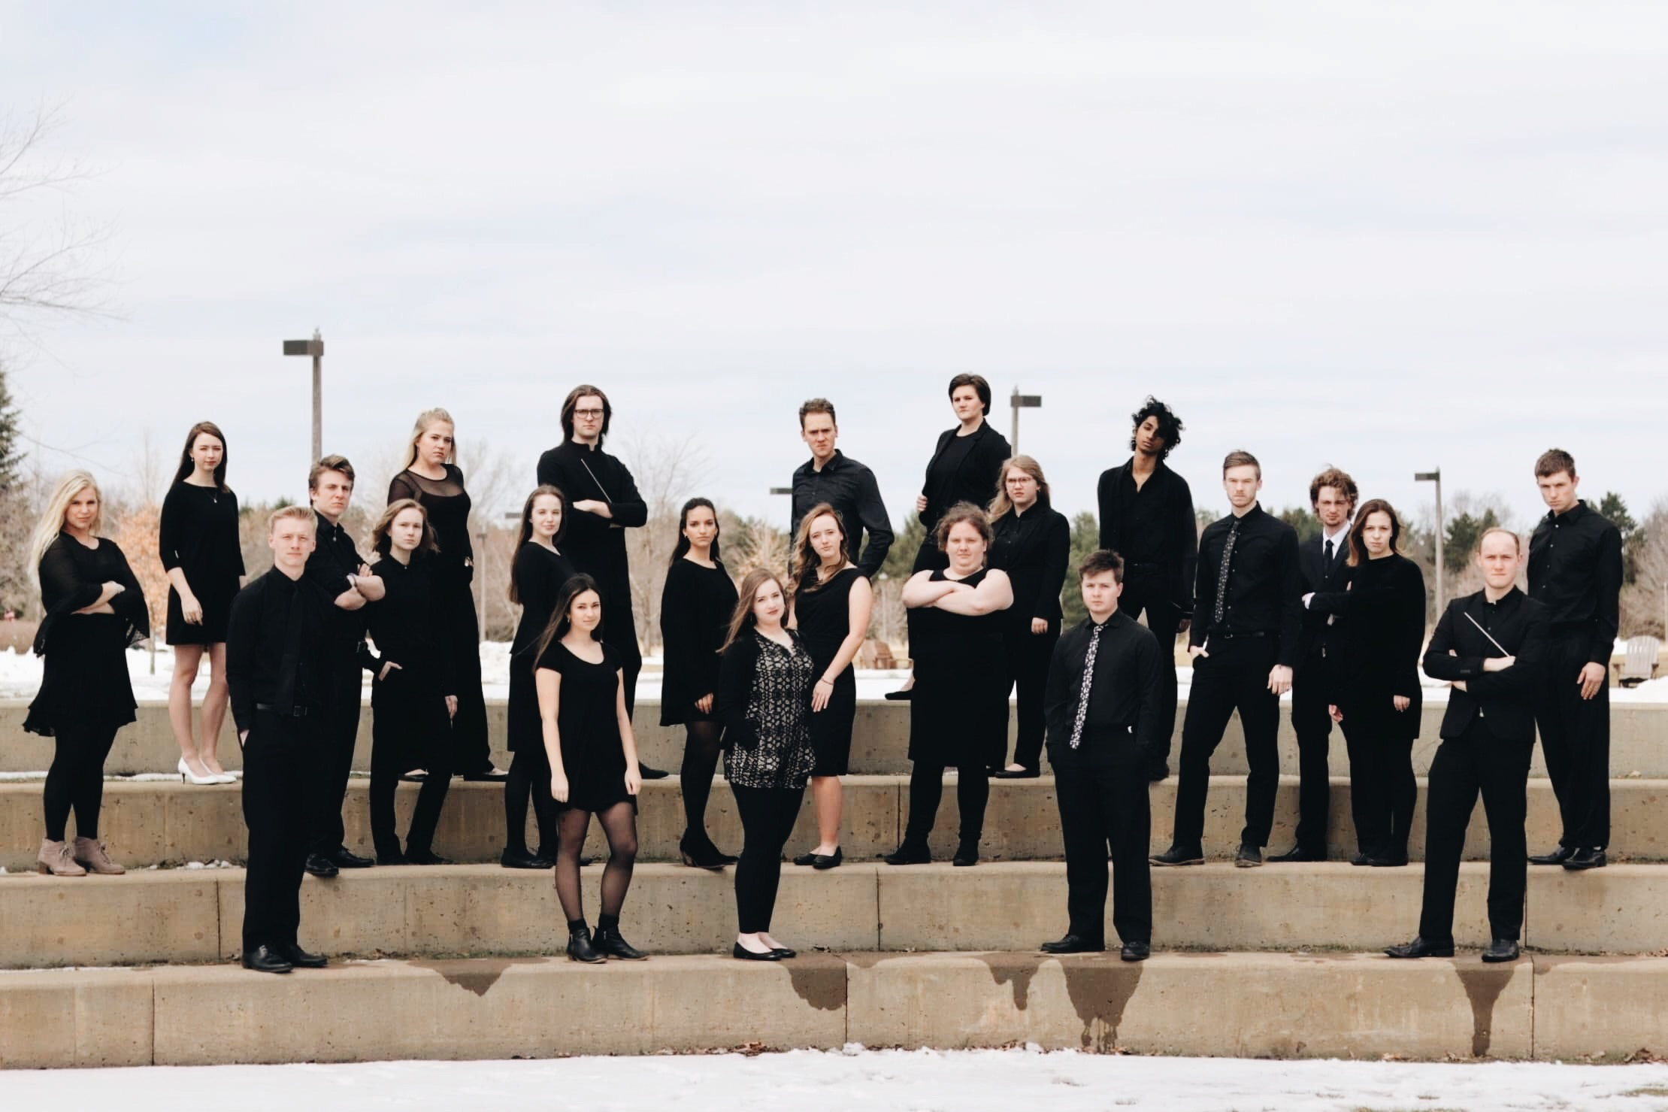

*An Exploration of the Adverse Experiences of LGBTQIA+ Youth*

One Voice: OVation

“Love is a Human Experience, Not a Political Statement”

**Would You Harbor Me Ysaye M. Barnwell**

**Love Is Tesfa Yohannes Wondemagegnehu**

**Run to You Pentatonix**

**Arr. Ben Bram**

**Hello Heterosexuals Eric Lane Barnes**

The Gustavus Social Justice Choir

Founder and Artistic Director: Michael R. McKenzie* 19’

“Dancing through days with love in our hearts for those who’ve slipped away.

We give this song to you, a blessing let it be.

A quiet moment’s thought of peace and harmony”

**A Quiet Moment Jennifer Higdon\***

*Conductor: Duncan Matthew* 19’*

“I wish the river could sweep me away to never be seen again”

**Athabasca Cait Nishimura\***

*Conductor: Duncan Matthew* 19’*

*Accompanist: Paige Reiners 20’*

“O Lamb of God that takest away the sins of the world, grant us peace.

Lord, have mercy. Lord, grant us peace.”

**Lamb of God: Stories of Overcoming Religious Intolerance**

**Words: John 1:29, Mathew Shurka*, Darren Calhoun*, Peter Cruz*, Amanda Loucks\***

**Music: Samuel Barber\***

**Adaptation: Michael R. McKenzie* 19’**

*Narrator: Gustavus Chaplain Maggie Falenschek*

*Soloist: Natalie Johnson 21’*

“Can you hear the voice of the children softly pleading for silence in their shattered world? Angry guns preach a gospel full of hate, blood of the innocent on their hands.”

**Prayer of the Children Kurt Bestor**

**arr. Andrea S. Klouse**

“Never our despair, Never the least of us, Never turn away, Never hide your face…

O Love that burns, O Love that dwells in every human heart…

This evergreen, this heart, this soul, Now moves us to remark our world…

With every voice, in cloudless hope of our belonging here…

All of Us, Only in the Love, Only ever in the Love, Love that lifts us up!”

**Considering Matthew Shepard* (excerpts) Craig Hella Johnson\***

**Text: Michael Dennis Browne, Lesléa Newman, Craig Hella Johnson\***

*Featured Narrator/Soloist: Kaitlyn Peroutka 18’*

*Featured Guest Choir: One Voice: OVation*

*Accompanists: Samantha Walters 21’ and Paige Reiner 20’*

1. Recitation I
2. Recitation II
3. The Fence (that night)
4. Recitation III
5. I Am Like You/We Are All Sons (excerpt)
6. Recitation IV

**\*\* You Do Not Walk Alone Dominick DiOrio\***

1. Recitation X
2. All of Us

*Soloists: Liza Johnson, Hannah Mahr, Megan Nipe,*

*Members of OVation, and Kaitlyn Peroutka*

*-*Optional Selection-

“All We Need is Love.”

**Love is Love is Love is Love Abbie Betinis**

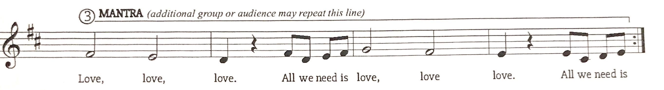

**For More Information about the Social Justice Choir follow us on social media!**

**Facebook: The Gustavus Social Justice Choir (@gsjchoir)**

**Instagram: @gsjchoir**

**or visit our website:** [**https://mmckenzi1.wixsite.com/gsjc**](https://mmckenzi1.wixsite.com/gsjc)